**.** **Write a C program to find Factorial of a given number without using Recursion**

**INPUT:**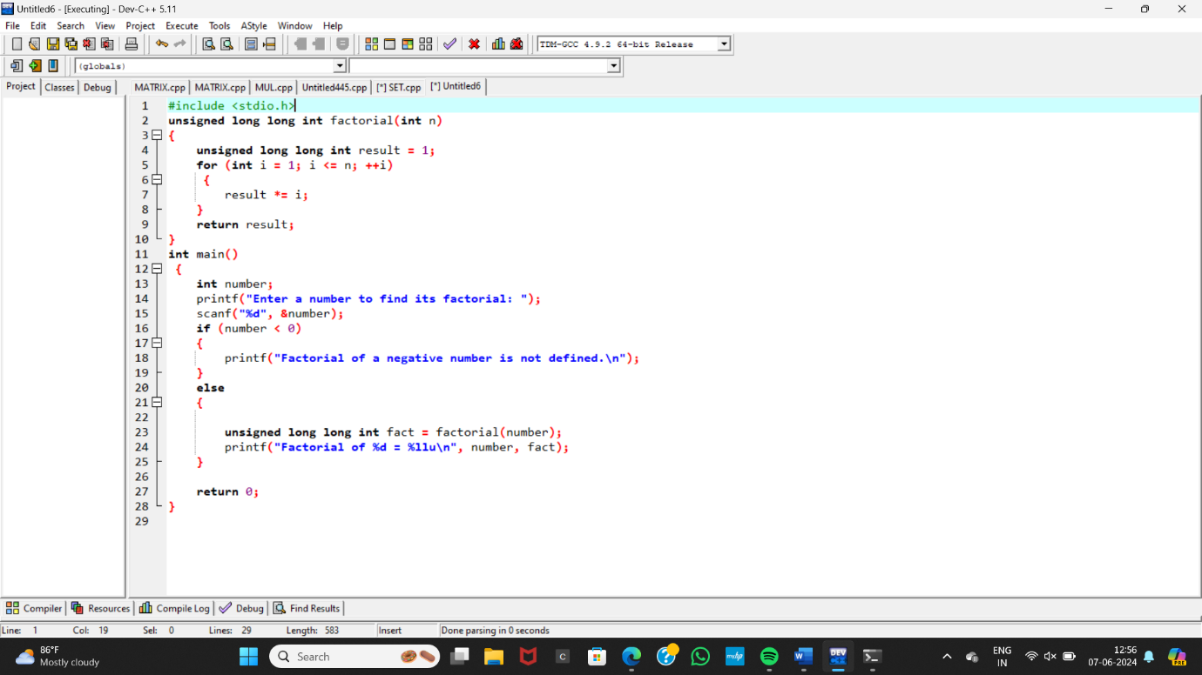

**OUTPUT:**

